**DAILY ONLINE ACTIVITIES SUMMARY**

|  |  |  |  |  |  |  |  |  |
| --- | --- | --- | --- | --- | --- | --- | --- | --- |
| **Date:** | **19/06/2020** | | | | | **Name:** | **Katira Krishna J** | |
| **Sem & Sec** | **8th A** | | | | | **USN:** | **4AL16CS045** | |
| **Online Test Summary** | | | | | | | | |
| **Subject** | | **BDA** | | | | | | |
| **Max. Marks** | | **30** | | **Score** | | | **24** | |
| **Certification Course Summary** | | | | | | | | |
| **Course** | **Data Analysis with python** | | | | | | | |
| **Certificate Provider** | | | **Cognitiveclass.ai** | | **Duration** | | | **10 hours** |
| **Coding Challenges** | | | | | | | | |
| **Problem Statement: Python program to print pascal’s triangle for n number of rows given by user** | | | | | | | | |
| **Status: Completed** | | | | | | | | |
| **Uploaded the report in Github** | | | | | **Yes** | | | |
| **If yes Repository name** | | | | | **Krishna_Katira** | | | |
| **Uploaded the report in slack** | | | | | **Yes** | | | |

Online Test Details:

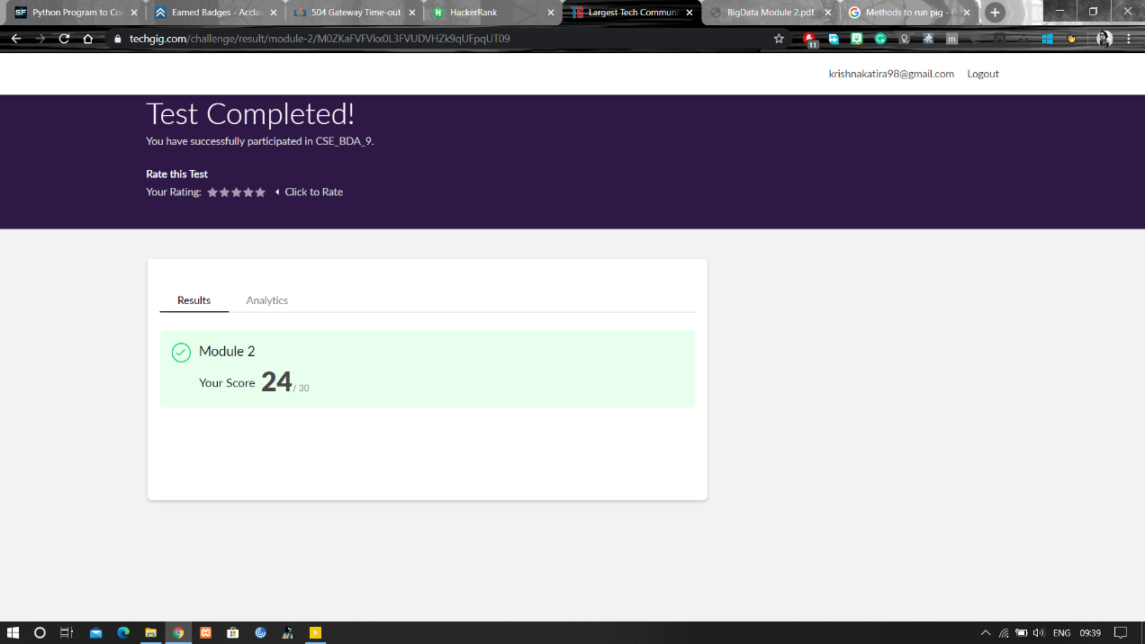

Certification Course Details:

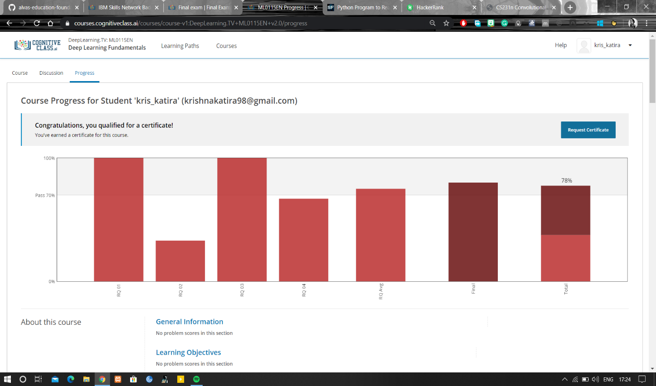

Coding Challenges Details:

**Program:**

n=int(input("Enter number of rows: "))

a=[]

for i in range(n):

a.append([])

a[i].append(1)

for j in range(1,i):

a[i].append(a[i-1][j-1]+a[i-1][j])

if(n!=0):

a[i].append(1)

for i in range(n):

print(" "*(n-i),end=" ",sep=" ")

for j in range(0,i+1):

print('{0:6}'.format(a[i][j]),end=" ",sep=" ")

print()